INFORMATION MANAGEMENT

EXERCISE 3

1. List all employees whose last names begin with P.

SELECT f_name, l_name FROM employee_data WHERE l_name LIKE 'P%';

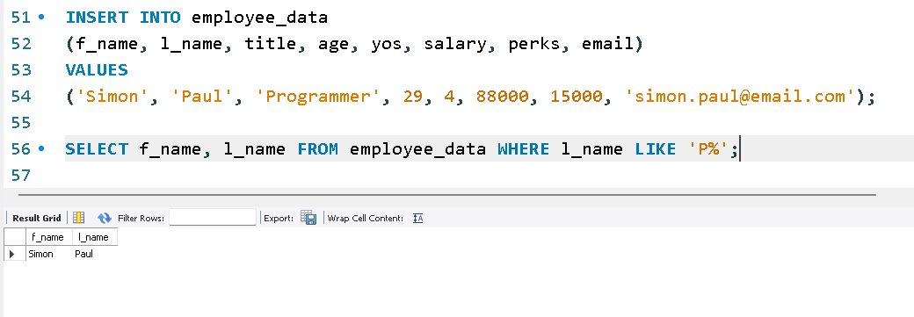

2. Display the names of all employees in the marketing division.

SELECT f_name, l_name FROM employee_data WHERE title LIKE '%Marketing%';

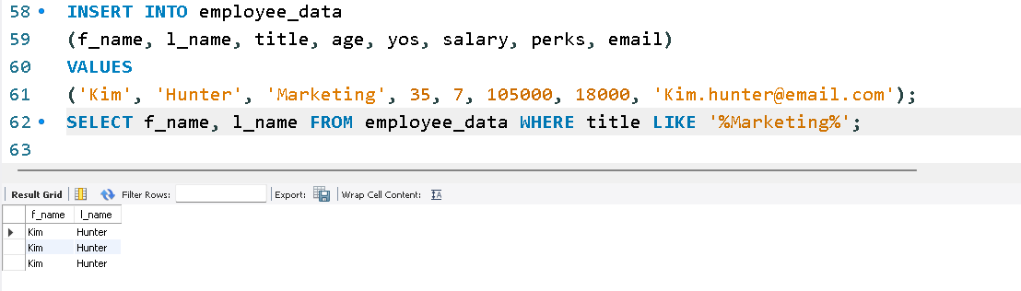

3. What will the following statement display?

SELECT f_name, l_name, salary FROM employee_data WHERE f_name LIKE '%k%';

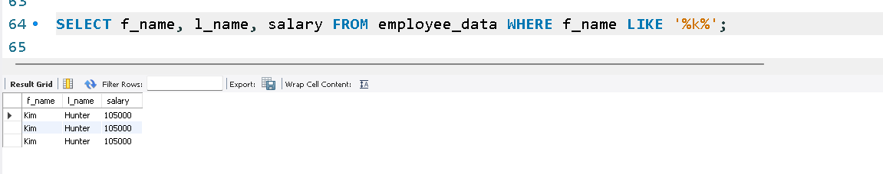

4. List the last names and titles of all programmers.

SELECT l_name, title FROM employee_data WHERE title LIKE '%Programmer%';

